Introducing Bootstrap.

Need reasons to love Bootstrap? Look no further.

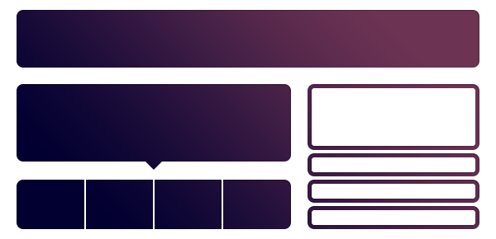

Level of difficulty: 4-10 (with the understanding of HTML/CSS)

Time needed to discus: 1-2 hours

Introduction:

* Basic web terms HTML /CSS / Java script
* What is Bootstrap frame front-end fame-work?
* Benefits of its use, built in features
* Documentation and resources

Part 1:

**Grid layouts**

* How grid layouts apply to bootstrap
* Fluid grid system
* Responsive

Part 2:

**How to use the CSS in the HTML**

* Typography
* Tables
* Forms
* Buttons
* Icons
* Media responsive css

Part 3:

**How to use the Components**

* Navigation
* Dropdowns
* Progress bards
* Carousel
* Tooltips
* Popovers
* Collapse able
* Modals

**Documentation:**   
<http://twitter.github.com/bootstrap>

http://bootswatch.com/

for good themes

<https://wrapbootstrap.com/>

Name: Joshua Martinez.

@media (max-width:480px){

}

@media (min-width:481px) and (max-width:767px) {

}

…